**Skills** ____________________________________________________________________________________________

|  |  |  |  |  |
| --- | --- | --- | --- | --- |
| Programming skills | Data Science | Communication | Managerial skills | Software Proficiency |
| C  C++  Java  Python  Django | Data visualization  Data analysis  Machine Learning  Deep Learning  SQL | Written communication  Verbal communication  Active listening  Presentation skills | Teamwork  Leadership  Project management  Project planning  Problem-solving | Ms Office,Git and GitHub  Jupyter notebook  Pycharm,Vscode  GoogleApplications |

**Experience** _______________________________________________________________________________________

|  |  |  |  |  |
| --- | --- | --- | --- | --- |
| **Kryzotech (Internship)** |  | [**Kryzotech**](https://www.linkedin.com/company/kryzotech/) |  | **4 Months** |

• **Recommendation System**

• **Face Recognition System**

• **Classification Problems**

• **SQl**

**Education** ________________________________________________________________________________________

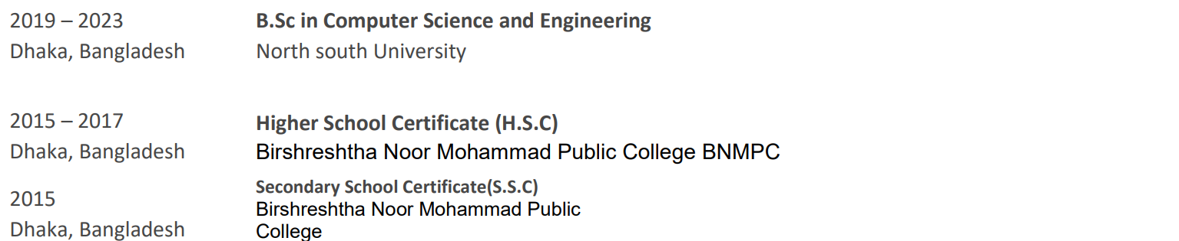**Projects** __________________________________________________________________________________________  
  
 **1.Multimodal Ai Doctor :**

- Description: In this project, I collected x-ray data of fractures and annotated those images with doctor suggestions and advice for NLP data. Then I trained them together so that when I upload an x-ray image of a fracture, it will give output as a description of that fracture and what should he/she do next like a real doctor.

1. **Pneumonia Detection Project :**

-Description: In this project, we have been collecting our own medical image dataset for pneumonia detection, which will be a dedicated dataset for Bangladeshi people.

**3. Agricultural Management syatem:**

-Description: A website build based on php, mysql, javascript, html, css, hack.An agricultural e commerce system where farmers can directly sell to the buyers.

1. **Brain Tumor Classification Project :**

- Description: This project focuses on the classification of brain tumors using various machine-learning algorithms.

**4. Cardiovascular Diseases Risk Prediction Project :**

- Description: This project focuses on predicting the risk of cardiovascular diseases using a diverse range of machine-learning techniques.

**5. Sleep-Health-and-Lifestyle Using Machine Learning techniques :**

* Description: This project delves into the realm of sleep health and lifestyle, examining various factors that influence sleep quality and duration.